|  |
| --- |
| Neusoft |
| CentOS & Weblogic & Oracle & Nginx |
| CentOS 6.4 Nginx 多虚拟主机配置 |

|  |
| --- |
| 成阳阳  2014/5/10 |
|  |

目录

方式一 ： 同一台服务器配置多虚拟主机 2

环境说明 2

主配置文件 nginx.conf 2

虚拟主机www.mattdamon.com配置 5

虚拟主机admin.mattdamon.com配置 6

本地测试 7

方式二 ： 利用nginx反向代理 映射多域名到不同的nginx服务 8

# 前言

Nginx conf配置中用到的基本语法

1. 配置服务器定义

|  |
| --- |
| upstream mall-servers {  server 10.1.17.95:7002;  } |

进阶

|  |
| --- |
| upstream mattdamon-servers {  sticky;  server 192.168.24.202:7002;  server 192.168.24.202:7003;  check interval=3000 rise=2 fall=5 timeout=3000 type=http;  check_http_send "GET / HTTP/1.0\r\n\r\n";  check_http_expect_alive http_2xx http_3xx http_4xx;  } |

1. 配置映射规则

|  |
| --- |
| #配置路径映射  location / {  proxy_pass http://mattdamon-servers;  proxy_redirect off;  proxy_set_header Host $host;  proxy_set_header X-Real-IP $remote_addr;  proxy_set_header X-Forwarded-For $proxy_add_x_forwarded_for;  }  location ~*\.(jsp|action|do)$ {  proxy_pass http://mattdamon-servers;  proxy_redirect off;  proxy_set_header Host $host;  proxy_set_header X-Real-IP $remote_addr;  proxy_set_header X-Forwarded-For $proxy_add_x_forwarded_for;  }  #配置路径映射  location ^~/path/ {  root /tpdata/nginx-data/webroot/;  }  #配置静态资源映射  location ~* \.(htm|html|gif|jpg|jpeg|png|bmp|ico|rar|css|js|zip|java|jar|txt|flv|swf|txt|wma)$  {  root /home/nginx-data/webroot/mattdamon;  } |

1. 配置代理转向和web部署

|  |
| --- |
| #1、代理转向  location / {  #设置身份认证  auth_basic "Please enter your password:";  auth_basic_user_file password/auth_users;  proxy_set_header Authorization '';  proxy_pass http://insu-vehicle-servers;  proxy_redirect off;  proxy_set_header Host $host;  proxy_set_header X-Real-IP $remote_addr;  proxy_set_header X-Forwarded-For $proxy_add_x_forwarded_for;  client_max_body_size 10m;  client_body_buffer_size 128k;  proxy_connect_timeout 90;  proxy_send_timeout 90;  proxy_read_timeout 90;  proxy_buffer_size 4k;  proxy_buffers 4 32k;  proxy_busy_buffers_size 64k;  proxy_temp_file_write_size 64k;  }  #2、web部署  location / {  root /home/nginx-data/webroot;  index index.html index.htm;  } |

1. 使用命令生成身份认证用户密码文件

#wget -c soft.v[ps](http://www.php100.com/fw/photo.html)er.net/lnmp/ext/htpasswd.sh;

bash htpasswd.sh

 htpasswd -c -d /usr/local/nginx/nginx-1.6.0/conf/password/auth_users  mattdamon

# 方式一 ： 同一台服务器配置多虚拟主机

## 环境说明

1. nginx虚拟机 ip： 192.168.24.100
2. 主机 ip 192.168.24.1 192.168.2.101
3. Nginx路径 /usr/local/nginx/nginx-1.6.0
4. 日志文件路径： /usr/local/nginx/nginx-1.6.0/logs

## 主配置文件 nginx.conf

1. 主目录配置为： /home/nginx-data/webroot
2. 虚拟主机配置文件所在目录： /usr/local/nginx/nginx-1.6.0/conf/vhosts/*;
3. 在root目录下创建index.html文件 写入 this is nginx root

|  |
| --- |
| #user nobody;  worker_processes 1;  #error_log logs/error.log;  #error_log logs/error.log notice;  #error_log logs/error.log info;  #pid logs/nginx.pid;  events {  use epoll;  worker_connections 1024;  }  http {  include mime.types;  default_type application/octet-stream;  log_format main 'ip[$http_x_forwarded_for] -user[$remote_user] -time[$time_local]'  ' -request-post-args[$request_body] -request-get-args[$args]'  ' -request-content[$request] -request-time[$request_time]'  ' -status[$status] -referer[$http_referer]'  ' -agent[$http_user_agent] -proxy-host[$remote_addr]';  #access_log logs/access.log main;  sendfile on;  #tcp_nopush on;  #keepalive_timeout 0;  keepalive_timeout 65;  gzip on;    #upstream baoxian-servers {  # server 10.94.211.22:80;  #}    server {  listen 80;  server_name localhost;  #charset koi8-r;  #access_log logs/host.access.log main;    #location /oauth2.0/ {  # proxy_pass https://183.60.15.173;  # proxy_redirect off;  # proxy_set_header Host $host;  # proxy_set_header X-Real-IP $remote_addr;  # proxy_set_header X-Forwarded-For $proxy_add_x_forwarded_for;  #}  location / {  root /home/nginx-data/webroot;  index index.html index.htm;  }  }  #include vhost  include /usr/local/nginx/nginx-1.6.0/conf/vhosts/*;  } |

## 虚拟主机[www.mattdamon.com](http://www.mattdamon.com)配置

1. 在/usr/local/nginx/nginx-1.6.0/conf/vhosts/路径下创建 [www.mattdamon.com.conf](http://www.mattdamon.com.conf)
2. Root目录为： /home/nginx-data/www.mattdamon.com
3. 在root目录下创建index.html文件 写入 this is www.mattdamon.com

|  |
| --- |
| server {  listen 80;  server_name www.mattdamon.com www.mattdamon.com;  access_log logs/host-access.www.mattdamon.log main;  # log_format access '$remote_addr - $remote_user [$time_local] "$request" '  # '$status $body_bytes_sent "$http_referer" '  # '"$http_user_agent" $http_x_forwarded_for';  location / {  root /home/nginx-data/www.mattdamon.com;  index index.html index.htm;  }  error_page 500 502 503 504 /50x.html;  location = /50x.html {  root /home/nginx-data/html;  }  location ~ /\.ht {  deny all;  }  } |

## 虚拟主机admin.mattdamon.com配置

1. 在/usr/local/nginx/nginx-1.6.0/conf/vhosts/路径下创建[admin.mattdamon.com.conf](http://www.mattdamon.com.conf)
2. Root目录为： /home/nginx-data/admin.mattdamon.com

3、在root目录下创建index.html文件 写入 this is admin.mattdamon.com

|  |
| --- |
| server {  listen 80;  server_name admin.mattdamon.com admin.mattdamon.com;  access_log logs/host-access.admin.mattdamon.log main;  # log_format access '$remote_addr - $remote_user [$time_local] "$request" '  # '$status $body_bytes_sent "$http_referer" '  # '"$http_user_agent" $http_x_forwarded_for';  location / {  root /home/nginx-data/admin.mattdamon.com;  index index.html index.htm;  }  error_page 500 502 503 504 /50x.html;  location = /50x.html {  root /home/nginx-data/html;  }  location ~ /\.ht {  deny all;  }  } |

## 本地测试

1. 修改主机host文件 映射192.168.24.100 域名 [www.mattdamon.com](http://www.mattdamon.com) 和 admin.mattdamon.com
2. 分别使用IP地址 和域名进行访问 结果如下：

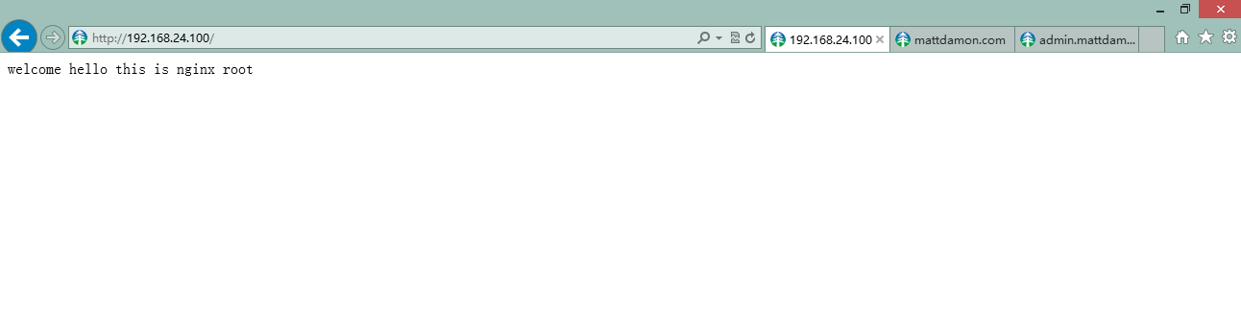

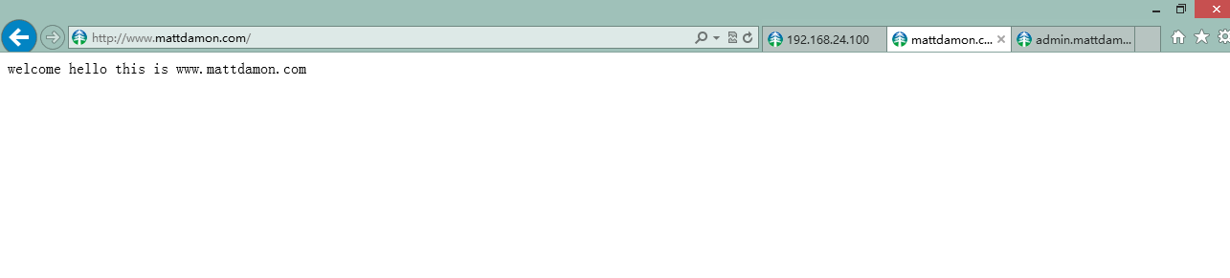

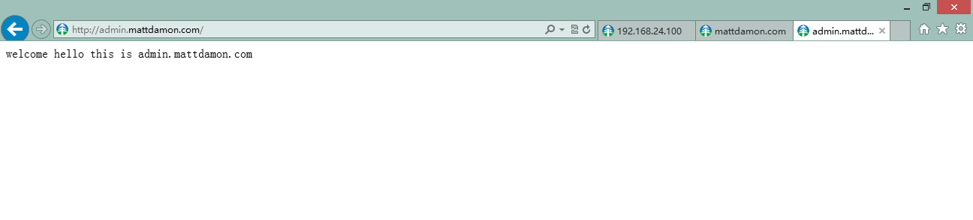

# 方式二 ： 利用nginx反向代理 映射多域名到不同的nginx服务